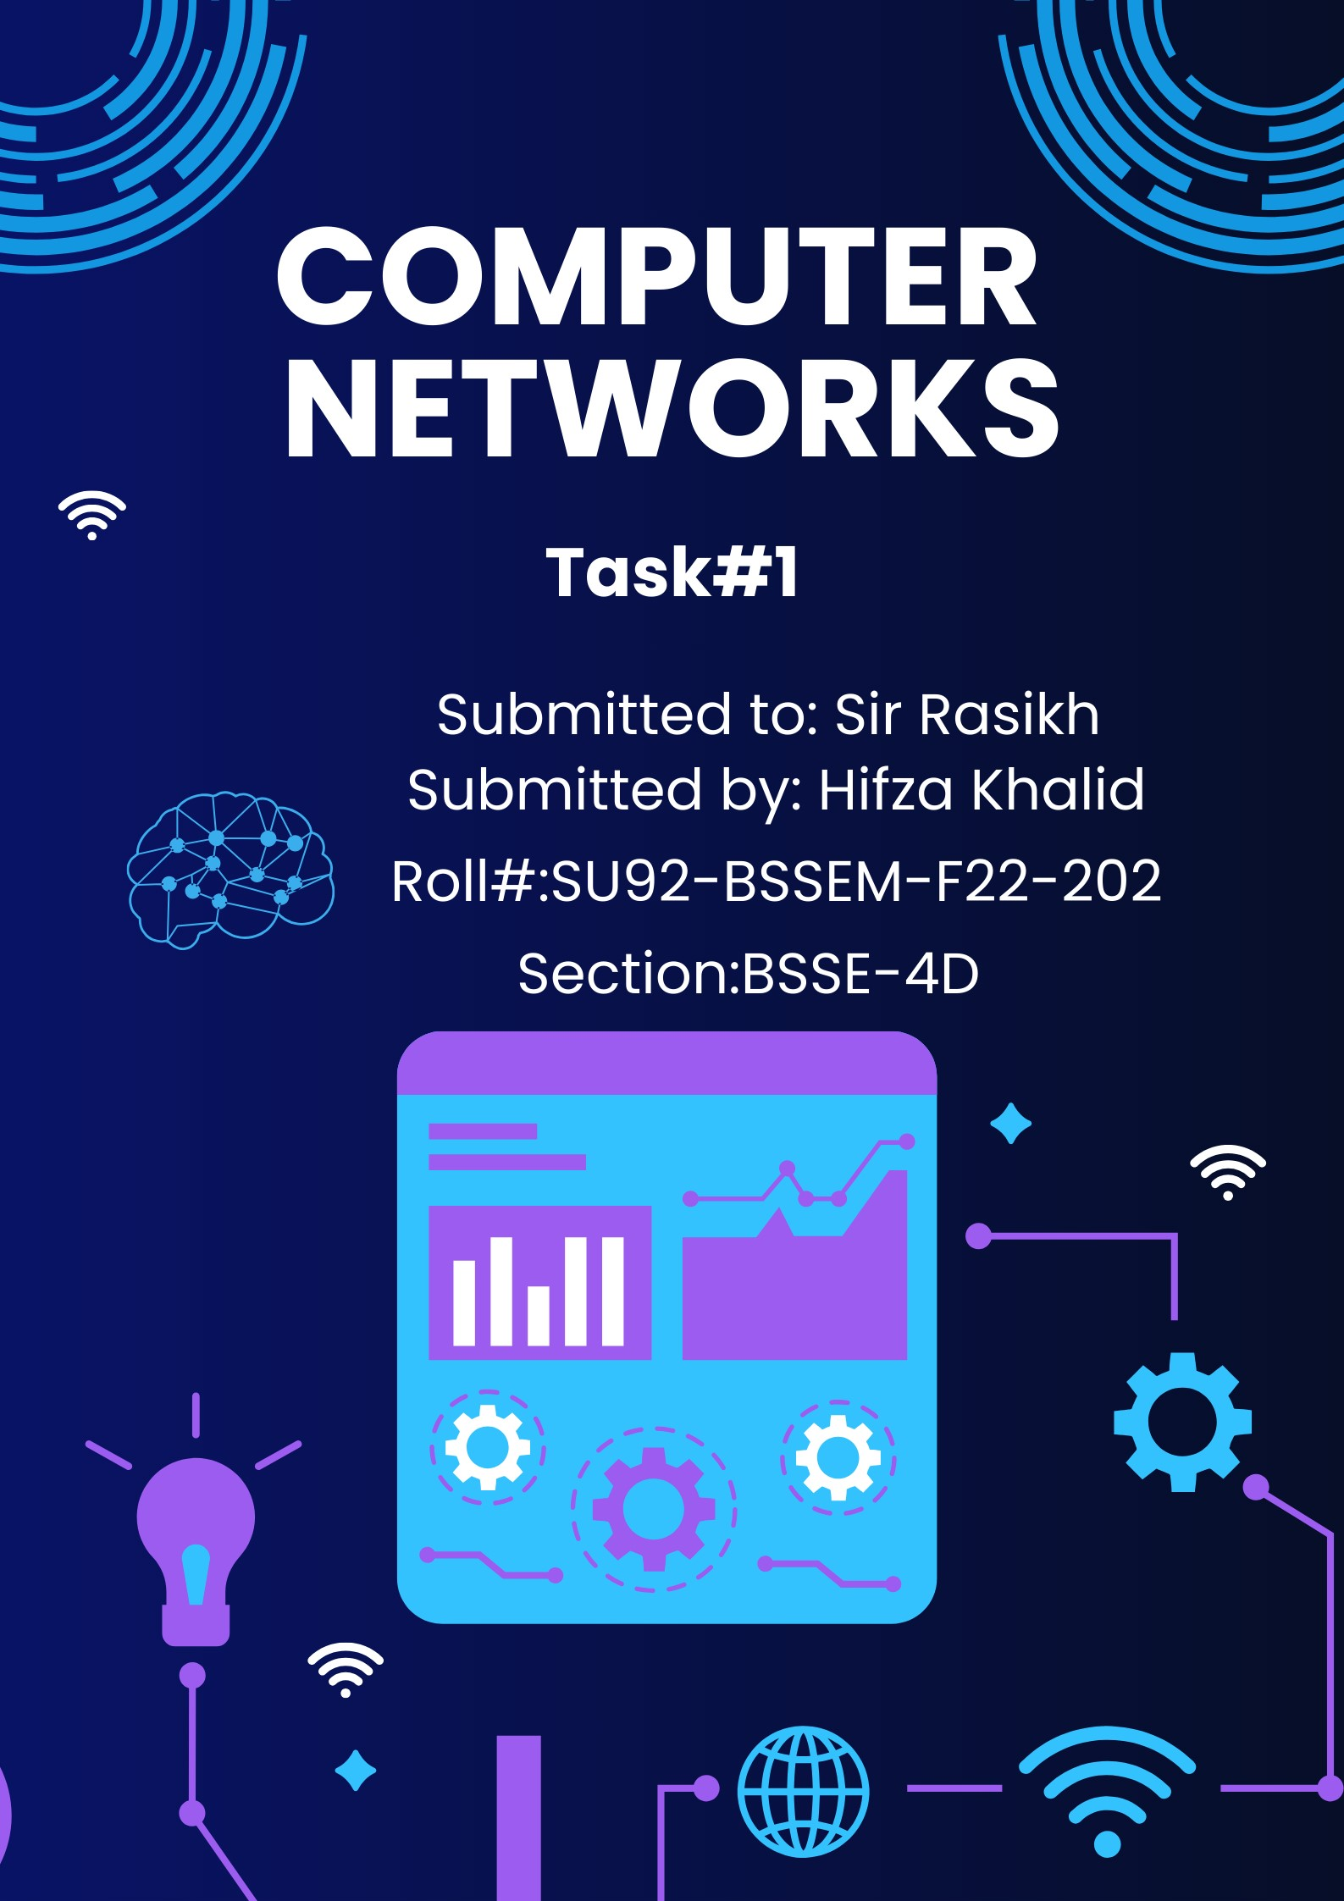

**Introduction to Packet Tracer:**

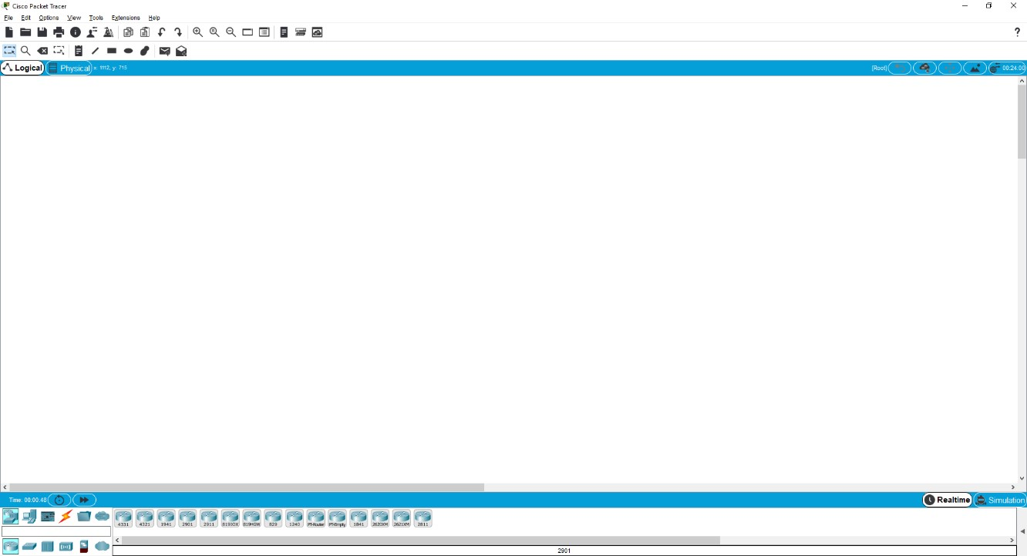

* Packet Tracer is a powerful router simulator created by Cisco Systems. It provides virtual interfaces to interact with physical environment.
* The purpose of Packet Tracer is to offer students and teachers a tool to learn the principles of networking as well as develop Cisco Technology specific skills.
* Packet Tracer is a simple Drag & Drop simulator that provides user-friendly environment.
* One of the biggest advantage of packet tracer is that when implementing a large scale of network in a physical environment it helps to establish the whole scenario in the simulator.
* Packet Tracer creates **.pkt & .pka** Extension when saving files.
* Packet Tracer **Include Routers, Switches, Hub, Servers, End Devices, Firewalls, And Multi user environment support**, so one can easily perform a large activity with its group members or partners on two computers. After completing of an activity both can merge a single Lab in one activity.

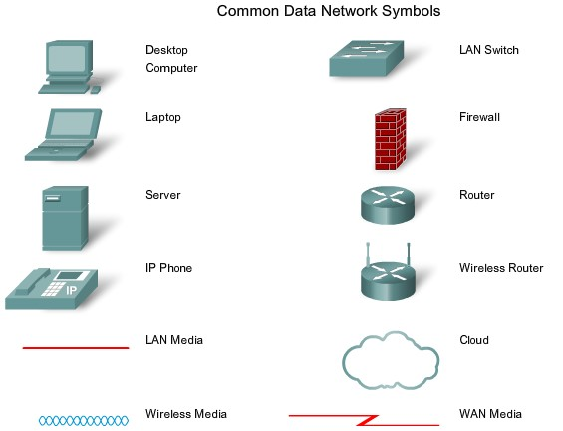

**Difference Between End & Intermediate devices:**

**Intermediary devices:**

A device that connects directly to end user devices or provides end user routing to other networks. For instance, a router is an example of intermediary devices Intermediary devices connect the individual hosts to the network and can connect multiple individual networks to form an internet-work.

**End Devices**

The network devices that people are most familiar with are called end devices. These devices form the interface between the human network and the underlying communication network. Some examples of end devices are: • Computers (work stations, laptops, file servers, web servers)

* Network printers
* VoIP phones
* Security cameras
* Mobile handheld devices (such as wireless barcode scanners, PDAs)

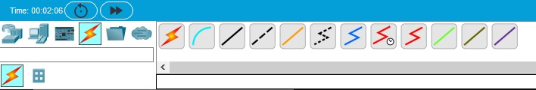

Selecting Connection Type

**Difference between Twisted Pair & Unshielded Twisted Pair:**

**Twisted pair:** **Twisted pair** cabling is a type of wiring in which two conductors (the forward and return conductors of a single circuit) are twisted together for the purposes of canceling out electromagnetic interference (EMI) from external sources.

**UTP**: is a four –pair medium used in verity of networks. UTP does not require te fixed spacing connection that is necessary with coaxile type connection. UTP is also finding increasing use in video applications, primarily in security cameras. Many middle to high-end cameras include a UTP output with setscrew terminals. This is made possible by the fact that UTP cable bandwidth has improved to match the baseband of television signals

**Symbols of Cable Type:**

**Console Cable (used to connect with a router)**

**Straight Through Cable (Used to Connect Different Devices**

**Copper Crossover cable (Used to connect with the same devices)**

 **Fiber (used in WAN environment)**

 **Phone (used in VOIP Phone)**

 **Coaxial cable (used in WAN emulation)**

 **Serial DCE Cable (Used in WAN links where clock rate is required)**

 **Serial DTE Cable (used in WAN link where clock rate is not required)**

**Task 1:**

**What is the difference between all the *routers*, and when to use them (mentioned in cisco packet tracer)**

|  |  |
| --- | --- |
| Router types | Uses |
|  | **Use for high-performance networking and advanced services like security and WAN optimization, especially in enterprise or branch office setups.** |
|  | **Use the ISR4321 router for small to medium-sized branch offices requiring reliable performance and integrated security.** |
|  | **The 1941 router is suitable for small branch networks needing basic routing and security features with moderate performance.** |
|  | **The 2901 router is ideal for small to medium-sized branches, offering enhanced performance, security, and flexible connectivity options.** |
|  | **The 2911 router is designed for medium-sized branch offices, providing higher performance, integrated security, and scalable network services.** |
|  | **The ISR4321 router is best for small to medium-sized branch offices, offering efficient performance, security, and WAN services in a compact form.** |
|  | **The 1941 router is suited for small branch offices, providing essential routing, security, and connectivity features at a moderate performance level.** |
|  | **The 2901 router is ideal for small to medium-sized branches, offering enhanced performance, security, and flexible modular connectivity options.** |
|  | **The 2911 router is well-suited for medium-sized branch offices, providing high performance, advanced security features, and scalable network services.** |
|  | **The Router_PT is a generic router in Cisco Packet Tracer, used for basic network simulations and educational purposes without specific model features or performance characteristics.** |
|  | **The Router_PT_Empty is a basic, unconfigured router in Cisco Packet Tracer, used for educational simulations where users need to manually configure the router from scratch.** |
|  | **The 1841 router is suitable for small branch offices, offering basic routing and security features with moderate performance capabilities.** |
|  | **The 2620XM router is designed for small to medium-sized networks, providing reliable routing with enhanced performance and support for additional services.** |
|  | **The 2621XM router is ideal for small to medium-sized branch offices, offering robust routing capabilities and support for advanced services and modular interfaces.** |
|  | **The 2811 router is suited for small to medium-sized networks, providing reliable performance, modularity, and support for integrated services and security features.** |

**Task 2:**

**What is the difference between all the switches, and when to use them (mentioned in cisco packet tracer)**

|  |  |
| --- | --- |
| Switches Types | Uses |
|  | **The Switch-PT is a basic, unconfigured switch in Cisco Packet Tracer used for educational simulations, allowing users to set up and practice network configurations without specific model details**. |
|  | **The Switch-PT-Empty is a basic, unconfigured switch in Cisco Packet Tracer, used for hands-on network simulations where users need to manually configure the switch from scratch.** |
|  | **The Push Button Toggle Switch IoT0 in Cisco Packet Tracer is used to simulate a physical button that can be toggled on or off, often utilized in IoT projects for triggering events or controlling devices.** |
|  | **The Rocker Switch in Cisco Packet Tracer is used to simulate a switch that can be toggled between two positions, often used in IoT projects to represent a physical switch for on/off control or similar functions.** |

**Task 3:**

**What is the difference between all the connection wires, and when to use them (mentioned in cisco packet tracer)**

|  |  |  |
| --- | --- | --- |
| **Wires images** | **Connection wires** | **Uses** |
|  | **Automatically Choose Connection Type** | It automatically selects the appropriate cable type for device connections. |
|  | **Console** | The console connecting wire (or console cable) is used to connect a computer or terminal to a router or switch's console port for configuration and management. |
|  | **Copper-Straight-Through** | The Copper-Straight-Through cable is used to connect devices of different types, such as a computer to a switch or a router to a switch, with the same pinout configuration on both ends. |
|  | **Copper Cross over Cable** | The Copper Crossover Cable is used to connect devices of the same type directly, such as two computers or two switches, by swapping the transmit and receive signals between the ends. |
|  | **Fiber** | The Fiber cable is used for high-speed, long-distance network connections, transmitting data via light signals through optical fibers. |
|  | **Phone** | The Phone cable is used for connecting telephones or fax machines to a telephone line, providing analogue voice communication. |
|  | **Coaxial** | The Coaxial cable is used for transmitting data, video, and audio signals over long distances, commonly used in cable television and broadband internet connections. |
|  | **Serial DCE** | The Serial DCE (Data Communications Equipment) cable is used for connecting devices like routers and modems where the DCE device provides the clock signal and data transmission, often used in serial communication setups. |
|  | **Serial DTE** | The Serial DTE (Data Terminal Equipment) cable is used to connect a terminal device, such as a computer or router, to a Data Communications Equipment (DCE) device, like a modem or switch, in serial communication setups. |
|  | **Octal** | The Octal cable is used for connecting devices with an octal interface, often found in some network equipment for specific configurations or legacy systems, though it's less common in modern setups. |
|  | **IoT Custom Cable** | The IoT Custom Cable is used for connecting Internet of Things (IoT) devices with specific or proprietary interfaces, allowing for tailored connectivity in IoT applications. |
|  | **USB** | The USB (Universal Serial Bus) cable is used for connecting a wide range of devices to computers and other electronics for data transfer, power supply, or device communication. |